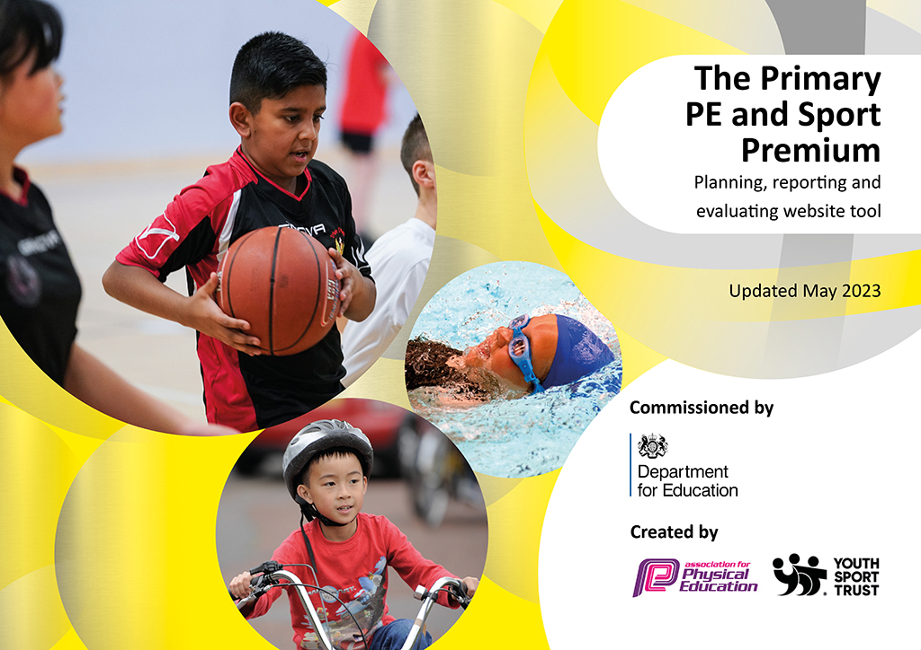
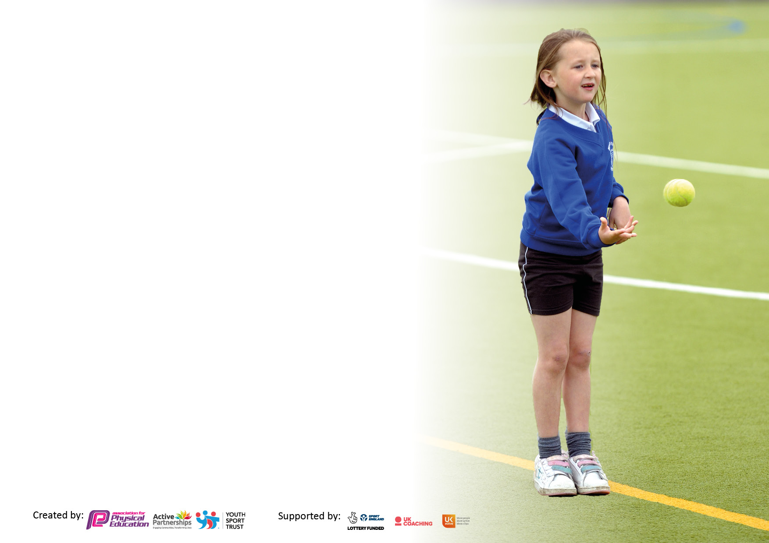

It is important that your grant is used effectively and based on school need. The Education Inspection Framework makes clear there will be a focus on ‘whether leaders and those responsible for governors all understand their respective roles and perform these in a way that enhances the effectiveness of the school’.

Under the Quality of Education Ofsted inspectors consider:
Intent - Curriculum design, coverage and appropriateness
Implementation - Curriculum delivery, Teaching (pedagogy) and Assessment
Impact - Attainment and progress

To assist schools with common transferable language this template has been developed to utilise the same three headings which should make your plans easily transferable between working documents.

Schools must use the funding to make additional and sustainable improvements to the quality of Physical Education, School Sport and Physical Activity (PESSPA) they offer. This means that you should use the Primary PE and sport premium to:

- Develop or add to the PESSPA activities that your school already offer
- Build capacity and capability within the school to ensure that improvements made now will benefit pupils joining the school in future years
- The Primary PE and sport premium should not be used to fund capital spend projects; the school’s budget should fund these.

Pleasevisitgov.ukfortherevisedDfEguidanceincludingthe5keyindicatorsacrosswhichschoolsshoulddemonstrate animprovement.Thisdocumentwillhelpyoutoreviewyourprovisionandtoreportyourspend.DfEencouragesschools to use this template as an effective way of meeting the reporting requirements of the Primary PE and Sport Premium.

We recommend you start by reflecting on the impact of current provision and reviewing the previous spend.

Schools are required to publish details of how they spend this funding, including any under-spend from 2021/2022, as well as on the impact it has on pupils’ PE and sport participation and attainment. All funding must be spent by 31st July 2023.

We recommend regularly updating the table and publishing it on your website throughout the year. This evidences your ongoing self-evaluation of how you are using the funding to secure maximum, sustainable impact. Final copy must be posted on your website by the end of the academic year and no later than the 31st July 2023. To see an example of how to complete the table please click HERE.

Details with regard to funding
Please complete the table below.

Total amount carried over from 2021/22 | £0
Total amount allocated for 2021/22 | £17800
How much (if any) do you intend to carry over from this total fund into 2022/23? | £0
Total amount allocated for 2022/23 | £17800
Total amount of funding for 2023/23. To be spent and reported on by 31st July 2023. | £17800
Swimming Data
Please report on your Swimming Data below.

Meeting national curriculum requirements for swimming and water safety.

N.B. Complete this section to your best ability. For example you might have practised safe self-rescue techniques on dry land which you can then transfer to the pool when school swimming restarts.
Due to exceptional circumstances priority should be given to ensuring that pupils can perform safe self rescue even if they do not fully meet the first two requirements of the NC programme of study
What percentage of your current Year 6 cohort swim competently, confidently and proficiently over a distance of at least 25 metres?  N.B. Even though your pupils may swim in another year please report on their attainment on leaving primary school at the end of the summer term 2022.  Please see note above | 90%
What percentage of your current Year 6 cohort use a range of strokes effectively [for example, front crawl, backstroke and breaststroke]?  Please see note above | 87%
What percentage of your current Year 6 cohort perform safe self-rescue in different water-based situations? | 93%
Schools can choose to use the Primary PE and sport premium to provide additional provision for swimming but this must be for activity over and above the national curriculum requirements. Have you used it in this way? | No

Action Plan and Budget Tracking
Capture your intended annual spend against the 5 key indicators. Clarify the success criteria and evidence of impact that you intend to measure to evaluate for pupils today and for the future.

Academic Year: 2022/23 | Total fund allocated: £17800 | Date Updated: 7.7.2023
Key indicator 1: The engagement of all pupils in regular physical activity – Chief Medical Officers guidelines recommend that primary school pupils undertake at least 30 minutes of physical activity a day in school |  |  |  | Percentage of total allocation:
 |  |  |  | 12%
Intent | Implementation |  | Impact | Total: £2183
Your school focus should be clear what you want the pupils to know and be able to do and about  what they need to learn and to  consolidate through practice: | Make sure your actions to achieve are linked to your intentions: | Funding allocated: | Evidence of impact: what do pupils now know and what can they now do? What has changed? | Sustainability and suggested next steps:
- Provide opportunities for daily physical activity during break and lunchtimes through confident lunchtime supervisors and Y6 Sports Leaders.  - All pupils to achieve at least 30 active minutes per day in school.  - To educate children in the benefits of a healthy active lifestyle.  - To encourage active travel methods and provide children the skills and resources to achieve this.  - Ensure PE and School sport offer develops competent and confident movers with the aim of inspiring lifelong participation in physical activity.  - Raise awareness of the best of the best places to take part in sport and physical activity outside school and in the local community. | - Purchase resources to support delivery of activities at break / lunchtimes and to widen variety of activities available.  - Provide training to Lunchtime Supervisors (Delivered by Active Schools) Training to engage pupils in physical activity, reduce behavior issues and improve levels of physical activity.  - Balance bike / Cycling and Scooter training provided throughout school. Give all children in school (EYFS to Y6) the opportunity to develop confidence in order to encourage active travel methods to and from school.  - Y6 Bikeability training  - Y1 Balance bike / cycle training (Get Cycling Project)  - Rec Balance Bike Training (BikeFutures)  - Y3,5,6 Scooter Training (Influencing Travel Behaviour Team)  - YN/YR Balance Bike Day (Pro-ride)  - Pedestrian Training provided to Y2 and Y4  - Recruit and train Sports Leaders to deliver activities at break and lunchtimes for younger children.  - Half term of training provided to Sports Leaders (see key indicator 2) | £1833  £0  £0  £350  £0  £0 (accounted for in KI2) | Sports Leaders competent and confident in leading and delivering activities and encouraging more children to participate in fun, inclusive activities. Wider variety of resources to encourage wider participation (cheerleading, tchoukball, bouncy hoppers etc)  Impact monitored through Living Streets Travel Tracker:  - 86% Active Journeys 22/23  - 1st in Top 10 Challenge in Leeds  - Sustainable Travel School of the Year – Modeshift Stars – 2nd year running  - Big Walk and Wheel – 170th Nationally | To also use Aces for a Monday lunchtime club, to support Sports Leaders to provide a lunchtime activity for younger children and provide ideas for the rest of the week.  Current Year 5 Sports Leaders continue into Year 6 and recruit new Sports Leaders in Year 5 and some in Year 6.
Key indicator 2: The profile of PESSPA being raised across the school as a tool for whole school improvement |  |  |  | Percentage of total allocation:
 |  |  |  | 21%
Intent | Total: £1833 |  | Impact | Total: £3824
Your school focus should be clear what you want the pupils to know and be able to do and about  what they need to learn and to  consolidate through practice: | Make sure your actions to achieve are linked to your intentions: | Funding allocated: | Evidence of impact: what do pupils now know and what can they now do? What has changed? | Sustainability and suggested next steps:
- To use PE and Sport to raise attainment in other areas of the curriculum and to improve engagement and behaviour of target groups.  - To use PE and Sport to support basic number skills and maths ability in children working below age-related expectations in Maths.  - To use PE and Sport to develop children holistically, including social, personal and thinking skills.  - To ensure PE and school sport are visible across school  - To develop Pupil Voice to develop curriculum and extra-curricular offer in school. | - Deliver targeted Intervention groups (led by Aces Community Education) in the following areas:  - R/KS1 Fundamental Movement Skills  - Y5/6 Sports Leader training  - R/KS1 Tagtiv8  - R/KS1 Social PE  - KS2 Social PE  - R/KS1 Mindful PE  - KS2 WTS in PE  - Share achievements of children in PE and Sport both in and out of school, within the school community, through assemblies, newsletters and website. | £3744  £0 | - Children show increased confidence in number facts in the classroom.  - 1 child in Y2 group moved from WTS to EXS. | - Continue to provide targeted intervention groups – liaise with class teachers to decide the focus and members of groups.  - Develop qualitative / quantitative methods to assess impact of Aces intervention groups.

Key indicator 3: Increased confidence, knowledge and skills of all staff in teaching PE and sport |  |  |  | Percentage of total allocation:
 |  |  |  | 21%
Intent | Implementation |  | Impact | £3764
Your school focus should be clear | Make sure your actions to | Funding | Evidence of impact: what do | Sustainability and suggested
what you want the pupils to know | achieve are linked to your | allocated: | pupils now know and what | next steps:
and be able to do and about | intentions: |  | can they now do? What has
what they need to learn and to |  |  | changed?:
consolidate through practice:
- To develop confidence and skill of all staff to teach all areas of the curriculum and to deliver engaging and effective extra-curricular clubs.  - Raise the quality of teaching and learning in PE and school sport by providing support to deliver an in-depth, inclusive and high-quality PE curriculum.  - To maintain subject knowledge and expertise of PE subject leader, ensuring school is up-to-date with current initiatives and developments in PESSPA. | - All classroom staff (teachers & TAs) to receive training from BtP around principles of PE, STEP principle and adapting activities)  - Provide training to HLTA responsible for delivering PPA PE to Y2-6. Level 5 PE Specialism course delivered by Beyond the Physical (AfPE accredited)  - Provide training to PE Admin Assistant TA. Level 3 PE and School Sport qualification, provided by Beyond the Physical (accredited by AfPE)  - To provide training, planning and resources through Beyond the Physical membership and online portal.  - Level 2 Netball Course  - To purchase Leeds Active Schools SLA which provides:  - Access to competitions across NW Leeds  - PE Subject Leader Days  - CPD programmes such as Sports Leader training, midday supervisor training, 1 to 1 subject leader advice and support.  - Youth Sport Trust membership  - Physical Activity Assembly | £0 (invoiced end 21-22)  £1135  £595  £475  £360  £1200 | - Increased staff knowledge and understanding  - HLTA progressed from Level 3 qualification (last year) to continued CPD with Level 5 qualification this year (ongoing). Using her developing expertise and knowledge to support EYFS team and transition into KS1.  - Quality of PE lessons improved as well as quality of extra-curricular clubs many of which are led by the same HLTA.  - PE Admin assistant trained to Level 3 standard. Able to support Level 5 HLTA and provide continuity in case of absence. Also increased quality of extra-curricular offer.  - EYFS PE brought more in line with rest of the school through BtP resources and online resources. Quality of EYFS teaching and learning improved and children more prepared to join KS1. | HLTA to complete Level 5 course (Autumn term 23-24)  PE TA to complete Level 3 course (Autumn term 23 – 24)  HLTA to observe and team teach with EYFS staff to develop their confidence with new BtP units.  Analyse results of PE Staff Survey to identify further areas of CPD required and complete further staff survey Summer term 2024.
Key indicator 4: Broader experience of a range of sports and activities offered to all pupils |  |  |  | Percentage of total allocation:
 |  |  |  | 33%
Intent | Implementation |  | Impact | £5818
Your school focus should be clear | Make sure your actions to | Funding | Evidence of impact: what do | Sustainability and suggested
what you want the pupils to know | achieve are linked to your | allocated: | pupils now know and what | next steps:
and be able to do and about | intentions: |  | can they now do? What has
what they need to learn and to |  |  | changed?:
consolidate through practice:
- To provide opportunities to take part in a diverse range of school sport through extra-curricular activities, competitions and clubs.  - To provide taster sessions and links to sports and physical activity clubs in the local community.  - To give all children the experience of a much wider range of sports than we can offer in school, so that they may choose to take up a new sport out of school.  - To develop relationships with community coaches and clubs.  - To provide opportunities through targeted competitions and activities provided by Active Schools.  - Swim England Membership and Leeds School Sports Association membership | - Deliver annual Health and Wellbeing fortnight  Northern Ballet – workshops with all classes from YN to Y6.  Karate – Zetsurin Karate Club (Whole school assembly and hosted Y2 & Y3 at the Dojo)  Y4 & Y6 visited the Ilkley Tennis Trophy  Tennis – Y1,2,3,4,5 had sessions at Grove Hill Tennis Club  Footloose Dance club – led sessions for Y1,2,3,4,5  - Other activities to support Disability Awareness week  PHGS Sports Leaders led disability sport taster session for Y1,2,3,4,5.  Y6 Sports Leaders led sponsored Go Noodle fundraising event for Mencap  Disability Sport Yorkshire led whole school assembly and then Goalball workshops with Y1,2,3,4,5,6  The FA visited to talk about their para football teams.  - Provide a range of extra-curricular clubs to all children in school.  Multiskills, Football, Dance/WUSU, Gymnastics, Netball, Wellbeing, Basketball, Tag Rugby, Dodgeball  - Access to resources and support from relevant organisations. | £1598  £0  £0 (coach KI5)  £0  £0  £0  £0  £250  £3800  £170 | - Excellent links created and maintained with local clubs, in particular Tennis, Karate, Squash, Dance, Football and Cycling.  - Good levels of participation in extra-curricular clubs (see appendix 1)  - High level of participation from Westgate children in local clubs in particular Karate, Football, Dance and Tennis.  - All children in school had access to a variety of sports and physical activity.  - Increased enjoyment and engagement in physical activity. | Signpost children and their families to local clubs including contact details.  Health and Wellbeing fortnight to continue annually – many activities and taster sessions free, so sustainable going forward.  Develop links with more local clubs to widen variety further – investigate badminton, sailing, rugby, running.

Key indicator 5: Increased participation in competitive sport |  |  |  | Percentage of total allocation:
 |  |  |  | 12%
Intent | Total: £1833 |  | Impact | £2210
Your school focus should be clear | Make sure your actions to | Funding | Evidence of impact: what do | Sustainability and suggested
what you want the pupils to know | achieve are linked to your | allocated: | pupils now know and what | next steps:
and be able to do and about | intentions: |  | can they now do? What has
what they need to learn and to |  |  | changed?:
consolidate through practice:
- To provide opportunities for all children to participate in inter-school and intra-school competition.  - To provide opportunities for less active, less confident and SEN children to participate in extra-curricular activity.  - To participate in varied external events to engage the less active children.  - To develop school competitive teams such as Football and Netball  - To provide administration support to enable PE Subject leader to organise attendance at events and competitions. | - To join PHGS inter-school competitions and festivals – one year group per half term.  Y1 – Football  Y2 – Handball  Y3 – Gymnastics  Y4 – Netball  Y5 – Badminton  Y6 – Rounders  - To enter as many Active Schools and SSP events as we are able to attend.  - To provide intra-school competition opportunities within school curriculum and on sports day.  - SEN children to attend SEN festivals and be invited to encourage and attend other events where possible.  - To attend Brownlee Triathlon again this year.  - To purchase competition standard / size netball posts.  - To continue post of PE Admin Assistant – 2 hours per week of admin and general support to PE Subject Leader.  - PE HLTA to complete Level 2 England Netball course | £0  £960 coach costs  £250  £1000  £360 (accounted for in KI3) | - Every child in Y1 – 6 participated in inter-school competition.  - Applying for Gold School Games Award for 5th year reflecting school commitment to competition participation and levels of extra-curricular activity.  - See Appendix 1 for evidence and details of events / competitions attended.  - Brownlee Triathlon attended and huge success.  - Netball team formed and attend weekly ‘Advanced Netball’ training club with PE HLTA. Took part in U11 Netball League with local schools.  - Good levels of SEN and PP attendance at extra-curricular events and competitions:  - 63% of SEN children attended 1 or more event  - 89% of PP children attended 1 or more event | Use Pupil Voice survey to decide upon clubs offered next year.  Review attendance data and registers to identify individuals / groups of children who may be targeted for events / competitions next year.  Continue to buy into Active Schools SLA to have access to a wide variety of events and festivals.  To continue to develop and train Netball team. Clubs to include beginner Netball, and Advanced Netball to identify and train players in KS1.

APPENDIX 1 – EVENTS ATTENDANCE

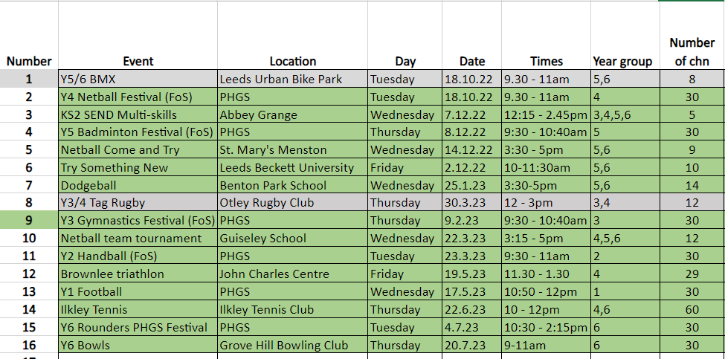

APPENDIX 2 – CLUB ATTENDANCE DATA

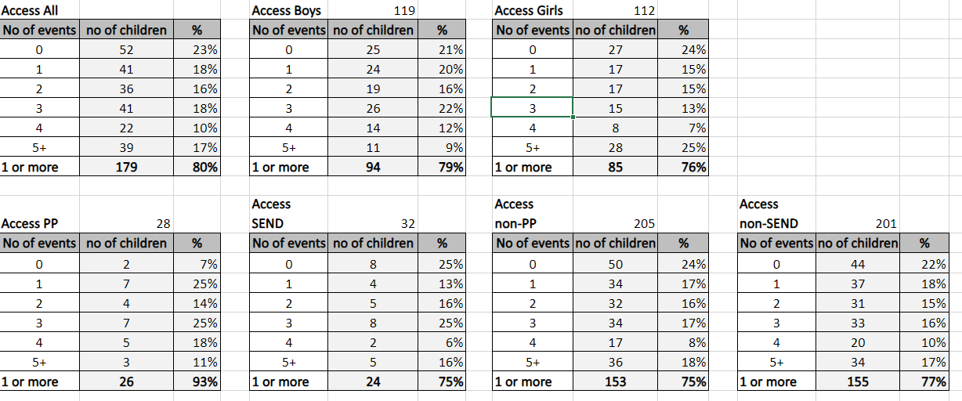

Signed off by
Head Teacher: | 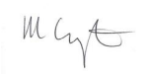
Date: | 21.7.23
Subject Leader: | H Hooper
Date: | 7.7.23
Governor:
Date: | 19.7.23

